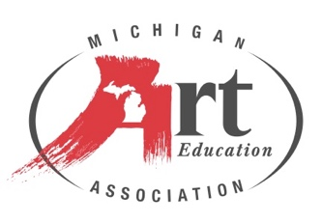

**2025 MAEA Middle Level Art Educator of the Year**

**Sarah DeKett** is a dedicated art educator, maker, and creative visionary currently making a profound impact as a middle school art teacher in Traverse City, Michigan. With an unwavering commitment to nurturing artistic talent, Sarah's students consistently produce award-winning artworks that captivate audiences at both local and state levels. With an illustrious career spanning 17 years, Sarah has left an enduring mark on the landscape of visual arts education in northern Michigan. Armed with a Bachelor of Arts degree in Art Education from Western Michigan University and a Master of Arts in Humanities from Central Michigan University, she brings a wealth of knowledge and expertise to her teaching practice.

In addition to her exemplary work within the classroom, Sarah is a recognized thought leader in the field of art education. She has served as a presenter at state and national conferences, where she shares her insights and innovative approaches to teaching art and digital photography. In her relentless pursuit of excellence, Sarah DeKett continues to inspire and empower the next generation of artists, leaving an enduring legacy that transcends the confines of the classroom.